Ms. McDonnell’s Tips – Food Webs April 2, 2020

Food Webs Vocabulary:

1. Sequence- the order in which things happen.

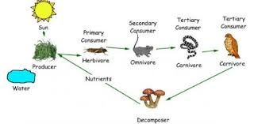

(primary means first, secondary means second and tertiary means third)

1. Intersecting- When two or more lines cross

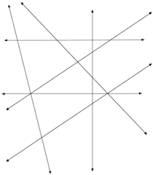

1. Microscope- An instrument used for looking at very small objects.

